**Big Data and modern technologies for processing information**

**Abstract**

In the recent year's, data generated by multiple types of stakeholders growing exponentially, computer scientists calling this data the Big data. This data needs to be stored in an efficient way. Traditional relational databases are becoming less effective in meeting the needs of Big data. In this research, we will analyze the main architectural solutions and alternatives for data storage such as NoSql.

**INTRODUCTION**

Recently, in connection with the development of the Internet, search engines are actively developing, social networks and highly loaded services, which must handle large arrays

information and answer a huge number of requests. This requires not only maximum accounting specifics of the information being processed but also transition to distributed computing. No server of any size is capable to provide the necessary productivity.

There are three basic requirements for heavily loaded applications:

* Lots of data: the largest of the web-applications process data volumes at

orders greater than those anticipated for relational database management.

* A huge number of users: numbered in millions, access to systems simultaneously and constantly.
* Complex data: as a rule, these applications are not simple processing of tabular data, which can be found in many commercial and business applications.

Relational database technologies that dominated the IT industry since 1980, began to show their weaknesses in the transition to web scales in these three aspects, so a growing number of people began to look for an alternative. Is NoSql suitable alternative to a relational database? We will review it and answer this question.[1]

**Big Data**

Currently, the term Big data means not only large volumes structured or unstructured data, how to store, sample, analyze, but also their properties, which are described as five V - volume, velocity, variety, value, veracity [2].

Consider the quantitative examples of some of the parameters:

* Volume (Volume) - 2.3 trillion gigabytes of information are generated every day. Submitted scientists from IBM, by 2020 will be generated 40 zettabytes of information.
* Velocity - in one trading session, the New York Stock Exchange generates about one

a terabyte of information about the auction, modern cars contain about 100 sensors, and

the number of network connections in computer networks can reach about 19 billion.

* Variety - in 2011, the volume of all health data reached 161 billion gigabytes, every month on the youtube site you can see over 4 billion hours of video, and 200

million active users of the Twitter service send about 400 million

every day

* Value: Which tends to the requirement for valuation of undertaking information? It is a most vital v in Big data. Value is primary buzz for Big data since it is imperative for organizations, IT foundation framework to store a substantial measure of values in database
* Veracity: The expansion in the scope of qualities ordinary of an extensive informational index. When we managing high volume, velocity and variety of information, the majority of the information is not going 100% right, there will be grimy information. Big Data and examination advances work with these sorts of information. [3]

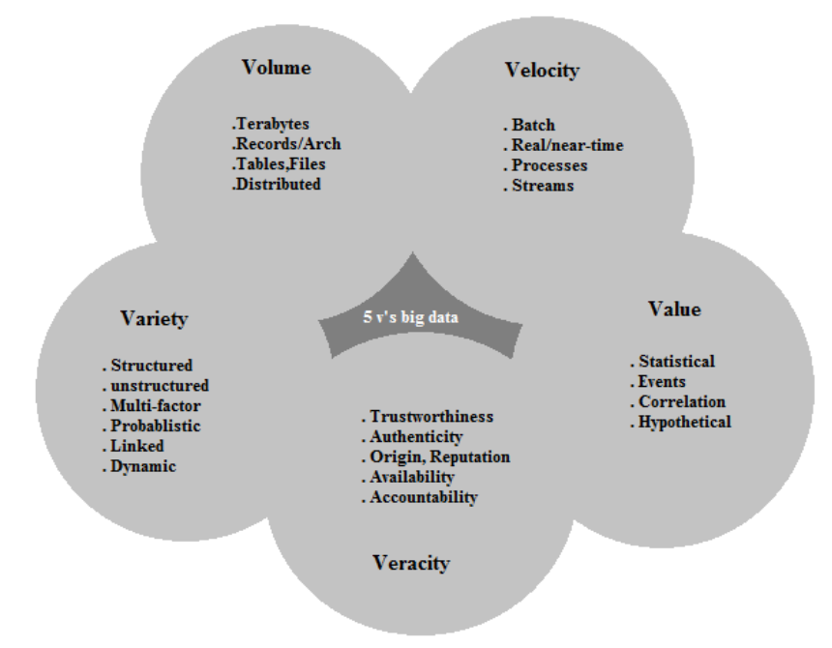

**Relational Database**

**NoSQL DATABASE**

**NOSQL DATABASE TYPES:**

**ADVANTAGES OF NOSQL**

**CONCLUSION**

[1] From SQL to NoSQL and back [Journal]

<http://www.osp.ru/os/2012/02/13014127/>

[2] https://blogs.gartner.com/doug-laney/files/2012/01/ad949-3D-Data-Management-Controlling-Data-Volume-Velocity-and-Variety.pdf

[3] http://www.sbsstc.ac.in/icccs2014/Papers/Paper2.pdf

Currently, the term Big data means not only large volumes structured or unstructured data, how to store, sample, analyze, but also their properties, which are described as three V - volume, velocity, variety [2].

Consider the quantitative examples of each of the parameters: